The Retrieving and Field Trials Club of SA Inc.
Beginners and Triallers
Retrieving Training Week-end
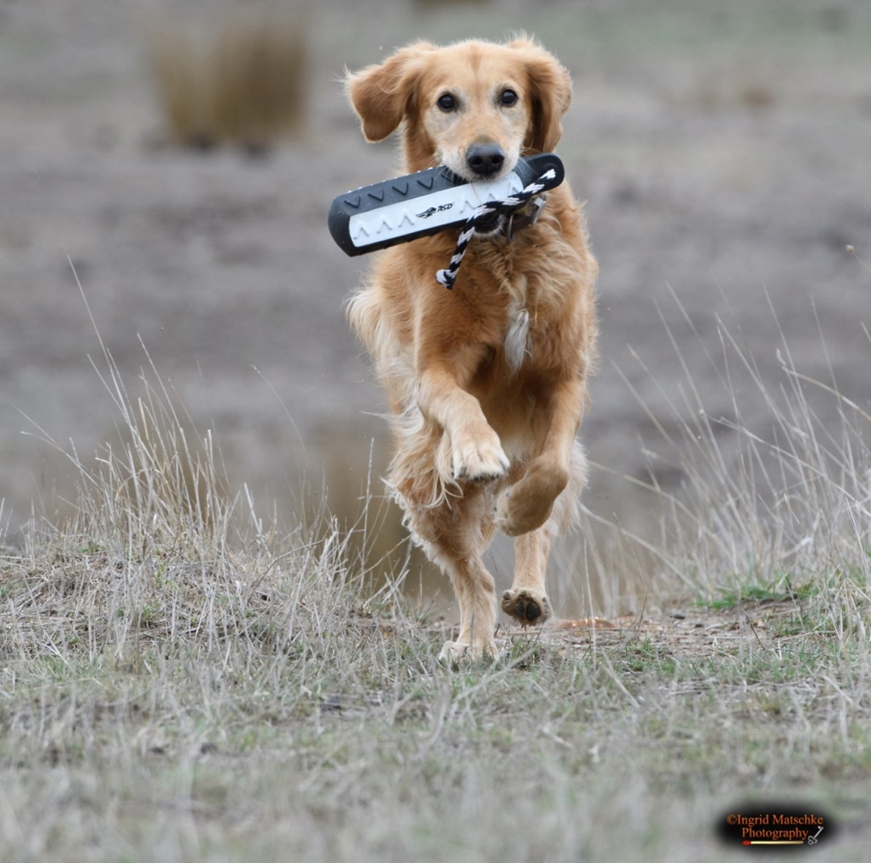

Saturday 13th

Sunday 14th

April 2024

Grand Cru Estate
174 Laubes Rd
Springton SA

Beginners do not need
to attend both days
but it would be
beneficial if you can

Please bring along your own refreshments and chair, training dummies,
dog’s water and bowl, lead, tie out stake or crate and your dog.

Cost: Non members $5.00 per dog per day, pay on the day.
Registration at 8.30 am, start time for Beginners 9.00 am
RAFTCOSA members FREE.

To book in please email Secretary: jtracey@ozemail.com.au

For enquiries please contact Graeme Allen:
Email: edwinna.allen@bigpond.com or Phone 0457 687 049

This information will be available on the Club website https://raftcosa.weebly.com/

Spectators welcome

Pizza will be available at the Restaurant

Camping available on site, no power

